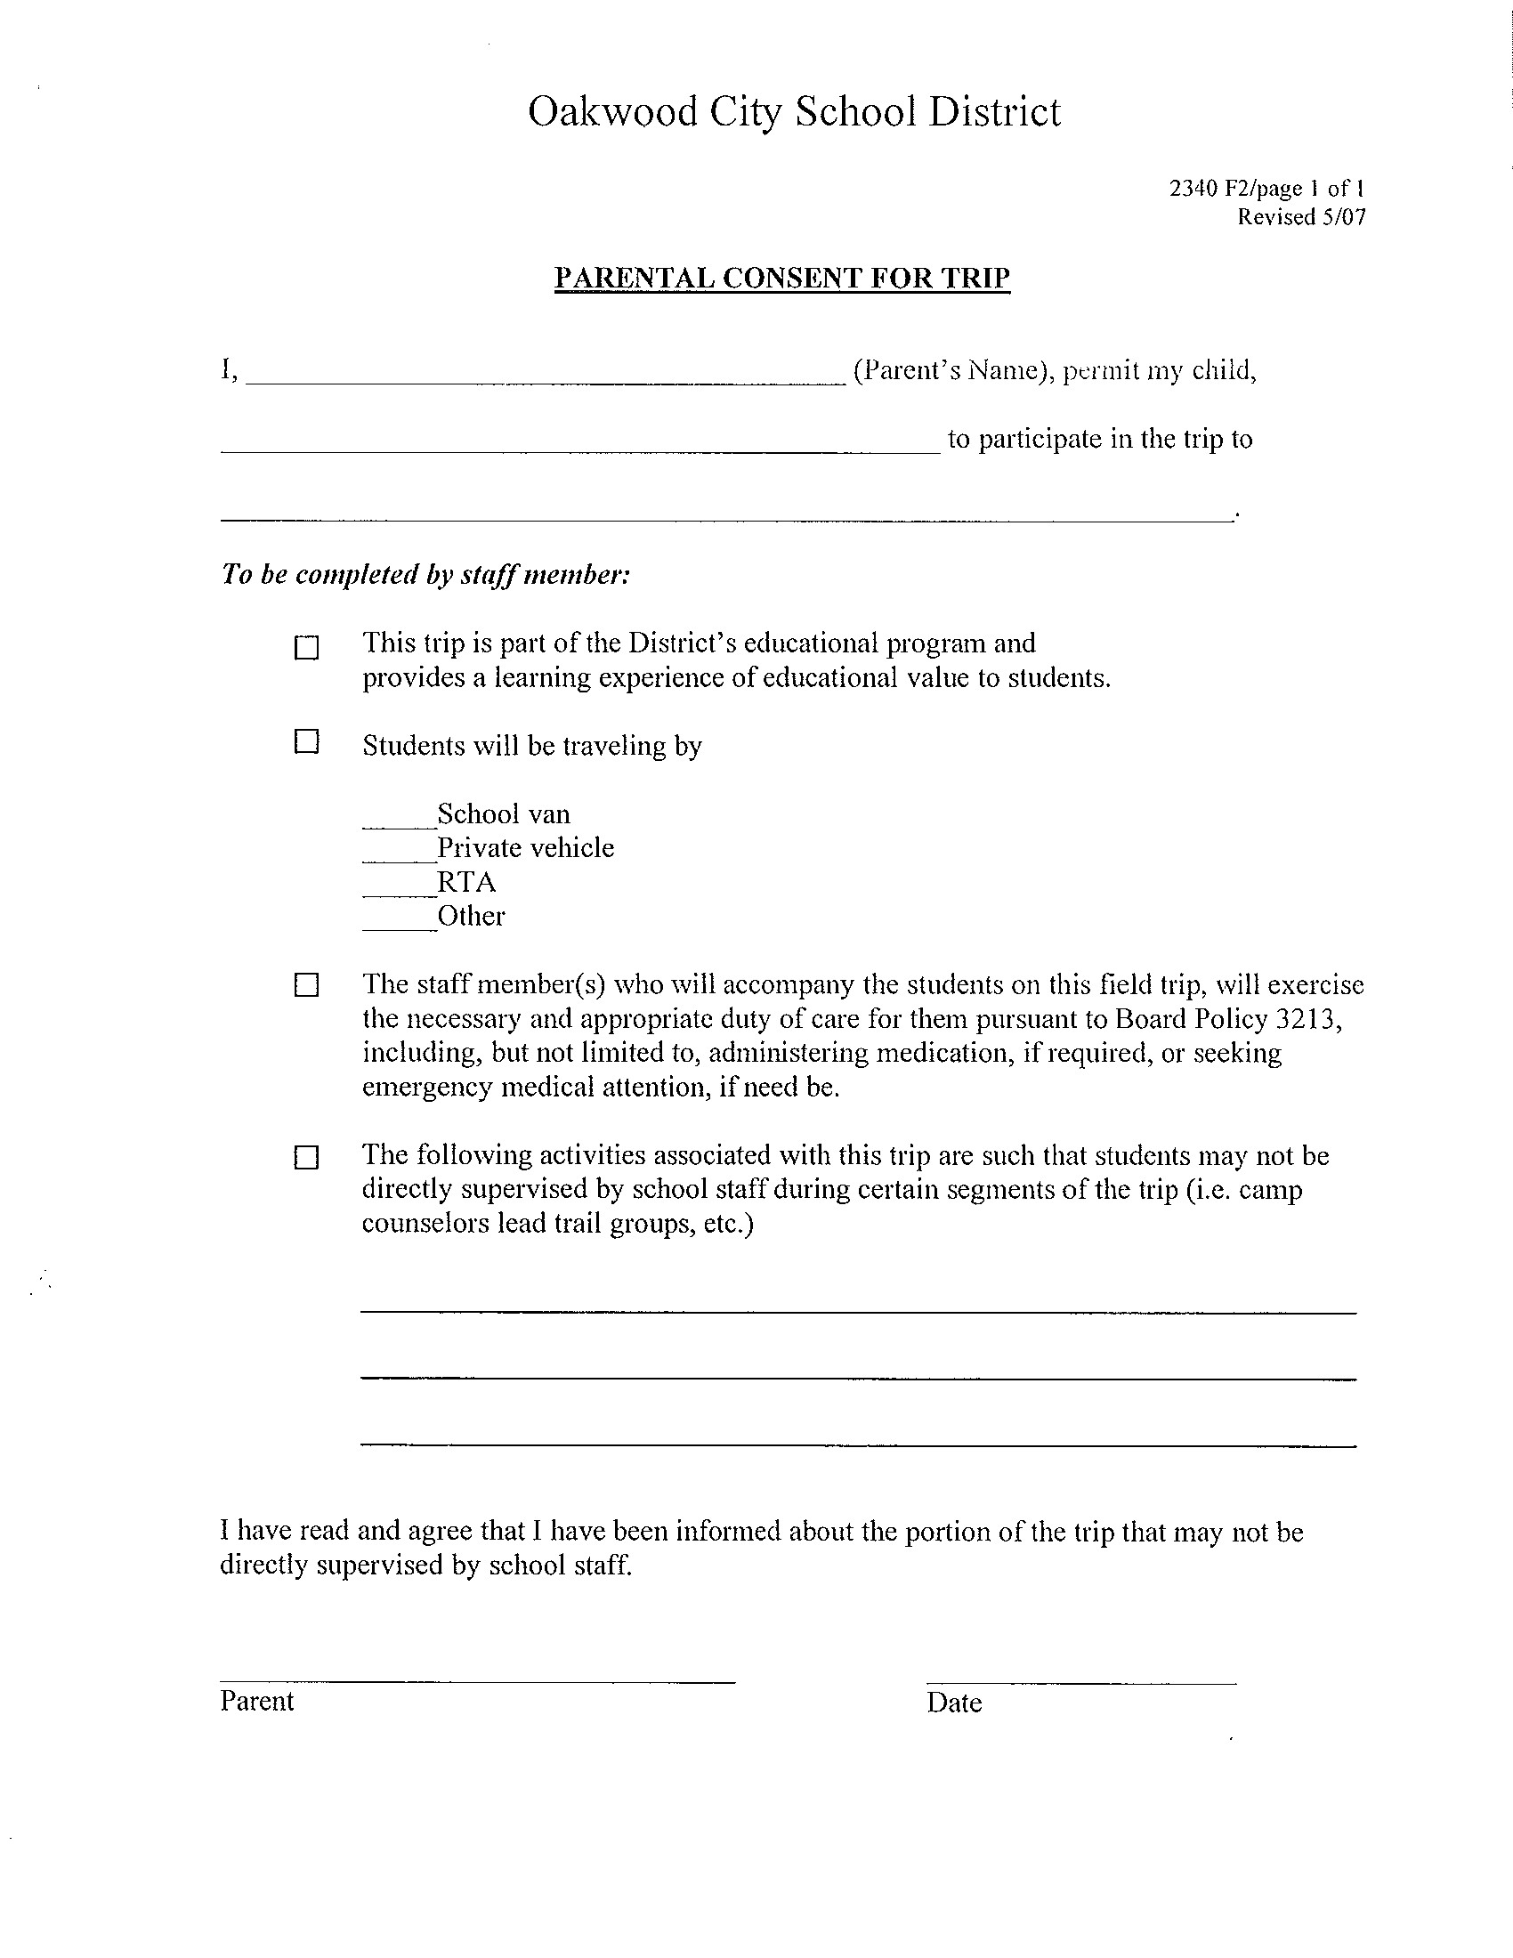

Not Applicable
Smith Elementary School

