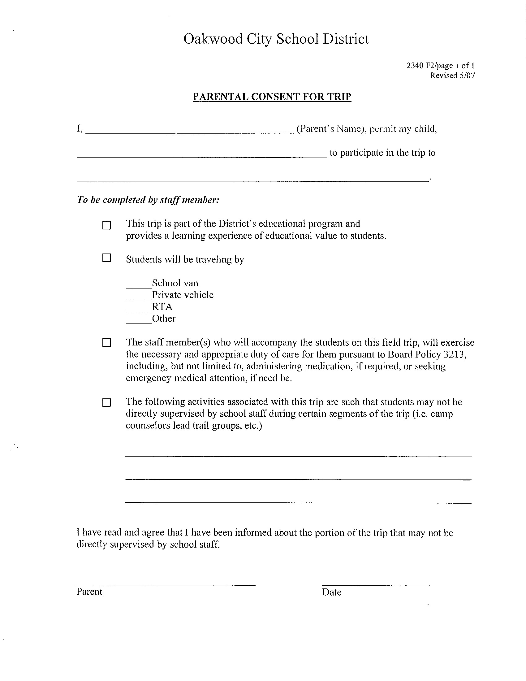

Not Applicable
Harman Elementary School

