2026 School MathCounts and AMC 8 difficult solutions
Sprint Round

6. [15 correct answers] What is the sum of the distinct positive divisors of 18?
Distinct means different
Positive means >0
Divisors are numbers that 18 can be divided by with no remainder
The distinct positive divisors of 18 are: 1, 2, 3, 6, 9, 18.
The sum of the distinct positive divisors is: 1+2+3+6+9+18=39

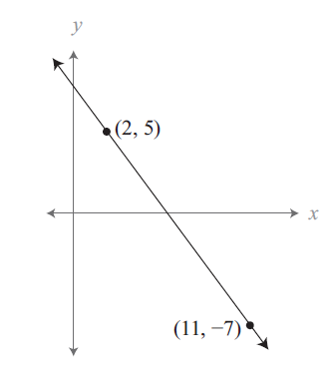
13. [11 correct answers] What is the slope of the line containing the points (2, 5) and (11, −7)? Express your answer as a common fraction.
Slope = rise / run = (y2-y1)/(x2-x1)
(x1,y1) = (2,5) and (x2,y2) = (11,-7)
Slope = [5 – (-7)]/(2-11) = 12/(-9) = -4/3

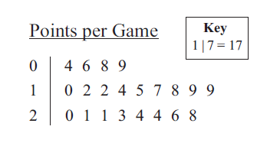
15. [8 correct answers] The stem-and-leaf plot shows the points a basketball player scored in 21 games. What is the player’s median number of points scored per game?
Median = The "middle" of a sorted list of numbers. To find the median, place the numbers in value order and find the middle number. If there is no middle number, the median is the average of the 2 numbers closest to the middle.
Sorted list of points per game:
{4, 6, 8, 9, 10, 12, 12, 14, 15, 17, 18, 19, 19, 20, 21, 21, 23, 24, 24, 26, 28}

Because there are 21 numbers, the middle number is the 11th number. The player’s median number of points scored per game is 18.

16. [4 correct answers] Sam is going to perform a juggling act for Crichton Middle School’s talent show. The performance will involve juggling three balls, each a different color. Sam must choose from red, blue, green, orange, purple and brown balls. How many different sets of three balls can Sam choose?
There are 6 different color balls. Because order does not matter this is a combination of 6 balls, taken 3 at a time, C(6,3).
$$C\left(n,r\right)=\frac{n!}{r!*\left(n-r\right)!}$$

$$C\left(6,3\right)=\frac{6!}{3!*3!}=\frac{6*5*4*3!}{3!*3!}=\frac{6*5*4}{3*2}=20$$

Thinking through it, rather than using the equation:
Sam has 6 different color balls. For his first ball, he has 6 choices. For his second ball, there are 5 choices left. For his last ball, there are 4 choices left.
6*5*4 = 120
However, we’ve counted the same sets multiple times, because we chose in order. For example, we picked {red, green, blue} and {green, blue, red}, which are the same set.
So, we need to divide 120 by how many ways we can arrange 3 balls. If you are putting 3 balls in order, you have 3 to choose from first, then 2 to choose from, then 1 left. You can arrange each set of balls into:
3*2*1 = 6 orders
For example: {red, green blue}, {red, blue, green}, {green, red, blue}, {green, blue, red}, {blue, red, green}, and {bleu, green, red}
So, we have counted each set 6 times.
Sam can choose 120/6=20 sets of 3 different color balls
21. [3 correct answers] What is the sum of all positive four-digit integers ABCD such that the two-digit numbers AB, BC and CD are each perfect squares?
List the 2-digit perfect squares: 16, 25, 36, 49, 64, 81
Find squares that end with the same number another square begins with:
16 – 64 – 49 : 1649
25
36 – 64 – 49 : 3649
49
64 – 49 -
81 – 16 – 64: 8164

1649 + 3649 + 8164 = 13,462

Target Round
4. [0 correct] Cecilia read consecutive pages of a 60-page comic book, and the sum of the page numbers she read was 300. What is the sum of all possible values for the page number of the final page that she read?
Summing the consecutive pages of a book is an arithmetic series.
The sum of an arithmetic series is: $\frac{first term+last term}{2}*(number of terms)$
For Cecilia it’s $\frac{first page+last page}{2}*(number of pages)$
$$number of pages=last page-first page+1$$
Note: number of pages is not simply the last page – the first page. That leaves out counting the first page. For example, if Ceclia read pages 3 to 5, 5-3=2. But Ceclia read pages 3, 4, and 5, which is 3 total pages. (I like to check my formulas with small numbers to make sure I have it correct.)
$Sum of page numbers=\frac{first page+last page}{2}*(last page-first page+1)$
To make things easier, let’s call the first page “f”, the last page “l”, and the number of pages “n”.
$$Sum of page numbers=300=\frac{f+l}{2}*\left(l-f+1\right)$$
$$300*2=\left(l+f\right)*\left(l-f+1\right)$$
$$600=\left(f+l\right)*number of pages$$

Find numbers where the product is 60, and find pairs that work. We can immediately rule out any pair with a number over 60+59 = 119
1, 600
2, 300
3, 200
4, 150
5, 120
6, 100: can f+l = 100, and n=6? {47, 48, 49, 50, 51, 52}; n=6, f+l=99
{48, 49, 50, 51, 52, 53}; n=6, f+l=101
If n is even, then (f+l) will be odd. If n is odd, then (f+l) will be even
8, 75: can f+l=75 and n=8? {34, 35, 36, 37, 38, 39, 40, 41}; n=8, (f+l)=75
10, 60: won’t work because both numbers are even
12, 50: won’t work because both numbers are even
15, 40: can (f+l)=40 and n=15? {13, 14, 15, 16, 17, 18, 19, 20, 21, 22, 23, 24, 25, 26, 27}; n=15, (f+l) = 40
20, 30: won’t work because both are even
24, 25: can (f+l)=25 and n=24? {1, 2, 3 … 23, 24}; n=24, (f+l)=25

What is the sum of all possible values for the page number of the final page that she read?
Sum of all possible values = 41+27+24 = 92

Another possible path to solution:
After you figure out that:
$$600=\left(l+f\right)*\left(l-f+1\right)$$
Notice that if (l+f) is even, then (l-f+1) is odd, and if (l+f) is odd, then (l-f+1) is even.
We need 2 factors of 600, where one is even, one is odd, and both numbers are under 119.
Prime factor 600
600=2³*3*5²
The only way to have factors where one is odd and on is even, is that all of the 2’s need to be a part of the same factor.
(2³) * (3 * 5²) = 8 * 75: works: (34+41) * (41-34 +1)
(2³ * 3) * 5² = 24 * 25: works: (1+24) * (24-1+1)
(2³ * 3 *5) * 5 = 120 * 5: too big
(2³ * 5) * (3 * 5) = 40 * 15: works (13+27) * (27-13+1)
(2³ * 5² * 3) * 1 = 600 * 1: too big
(2³ * 5²) * 3 = 200 * 3: too big
Sum of final pages = 41+24+27=92

6. [0 correct] Ethan draws four cards from a standard 52-card deck without replacement. What is the probability that no two of them will be the same rank or the same suit? Express your answer as a common fraction.
In a deck of cards there are 13 ranks and 4 suits. Ethan can draw any rank and suit for the first draw. For the second draw, he can only draw from 12 ranks and 3 suits. For the third draw, he can draw from 11 ranks and 2 suits. For the final draw, he can draw from 10 ranks and 1 suit.
For the first draw, Ethan can draw (13*4)/52 cards = 52/52
For the second draw, Ethan can draw (13-1)*(4-1)/51 cards = 36/51
For the third draw, Ethan can draw (13-2)*(4-2)/50 = 22/50
For the final draw, Ethan can draw (13-3)*(4-3)/49=10
Probability = $\frac{52*36*22*10}{52*51*50*49}=\frac{12*22}{17*5*49}=\frac{264}{4165}$

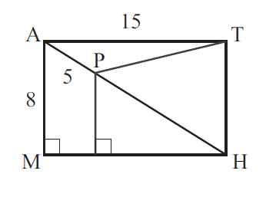
8. [2 correct] Rectangle MATH shown below has AM = 8 units, AP = 5 units and AT = 15 units. What is the area of triangle PTH? Express your answer as a common fraction.
Q
The trick to this problem is noticing the Pythagorean triple and labeling the point below P. Just because the problem doesn’t label a point doesn’t mean it’s not important.
Notice that 8 and 15 are the legs of the 8-15-17 Pythagorean triple. That means AH is 17.
PH=(AH – AP) = 17-5 = 12
Call the point on MH below P “Q.” Triangle PQH is similar to triangle AMH. Because they are similar,
AH/PH = MH/QH
12/17 = QH/15
QH = 15*12/17 = 180/17
For triangle PTH, if TH is the base, then QH is the height
Area of triangle PTH = ½ (bh) = ½ *(8 * (180/17)) = 720/17

AMC 8
16. [1 correct] Consider all positive four-digit integers consisting of only even digits. What fraction of these integers are divisible by 4?
The divisibility rule for 4 is that if the last 2 digits are divisible by 4, then the number is divisible by 4. So, we only have took look at the last 2 digits.
Divisible by 4: Not Divisible by 4:
00, 04, 08 02, 06
20, 24, 28 22, 26
40, 44, 48 42, 46
60, 64, 68 62, 66
80, 84, 88 82, 86

15 out of 25 total combinations = 15/25 = 3/5
You also could have noticed that if the tens digit is even, then numbers with the ones digit as 0, 4, or 8 were divisible by 4 and numbers with the ones digit as 2 and 6 are not.

18. [5 correct] In how many ways can 60 be written as the sum of two or more consecutive odd positive integers that are arranged in increasing order?
A sum of consecutive odd integers is an arithmetic series. The sum will be a multiple of the average of the numbers.
Two numbers (average 30): 29, 31
Three numbers (average 20): 3 odd numbers can’t add to an even number
Four numbers (average 15): An even number of consecutive odd integers will average to an even number
Six numbers (average 10): 7, 9, 11, 13, 15, 17
Ten numbers (average 6): -5, -3, -1, 1, 3, 5, 7, 9, 11, 13, 15: not all positive
There are 2 ways: Two numbers and six numbers

19. [7 correct] Miguel is walking with his dog, Luna. When they reach the entrance to a park, Miguel throws a ball straight ahead and continues to walk at a steady pace. Luna sprints toward the ball, which stops by a tree. As soon as the dog reaches the ball, she brings it back to Miguel. Luna runs 5 times faster than Miguel walks. What fraction of the distance between the entrance and the tree does Miguel cover by the time Luna brings him the ball?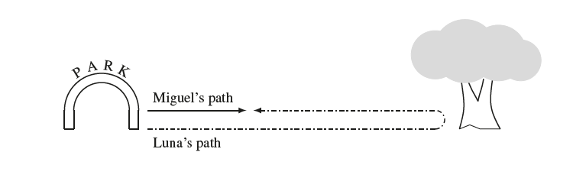
The key to this problem is realizing that Miguel and Luna run for the same amount of time.
M = Miguel’s speed. 5M=Luna’s speed
Total time = t
Distance Miguel travels = M*t
Distance Luna travels = 5M*t
Ratio of Miguel’s distance to Luna’s distance = (M*t)/(5M*t) = 1/5
Ratio of Miguel’s distance to total distance = (M*t)/(M+5M*t) = 1/6
Distance from park to tree = d
Total distance = 2d
Miguel goes 1/6 * 2d = 1/3 * d

20. [4 correct] The land of Catania uses gold coins and silver coins. Gold coins are 1 mm thick and silver coins are 3 mm thick. In how many ways can Taylor make a stack of coins that is 8 mm tall using any arrangement of gold and silver coins, assuming order matters?
8 gold coins – 1 way
5 gold and 1 silver coin – 6 ways (GGGGS, GGGGSG, GGGSGG, GGSGGG, GSGGGG, SGGGGG)
2 gold and 2 silver coins – 6 ways (GGSS, GSGS, GSSG, SSGG, SGSG, SGGS)
Total =13 ways

21. [5 correct] Charlotte the spider is walking along a web shaped like a 5-pointed star, shown in the figure below. The web has 5 outer points and 5 inner points. Each time Charlotte reaches a point, she randomly chooses a neighboring point and moves to that point. Charlotte starts at one of the outer points and makes 3 moves (re-visiting points is allowed). What is the probability she is now at one of the outer points of the star?
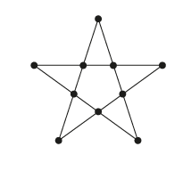
After 1st move, Charlotte is at and inner point. (outer points only connect to inner points)
Each inner point is connected to 2 outer points and 2 inner points
After 2nd move, 50% chance on an inner point and 50% chance on an outer point
After 3rd move: if started on outer point, 100% chance on an inner point
If started on and inner point, 50% chance on an outer point
50% * 50% = 25% or 1/4
O-I-O-I
O-I-O-I
O-I-I-O
O-I-I-I

24. [2 correct] The notation n! (read “n factorial”) is defined as the product of the first n positive integers. (For example, 3! = 1·2·3 = 6.) Define the superfactorial of a positive integer, denoted by n!, to be the product of the factorials of the first n integers. (For example, 3! = 1! · 2! · 3! = 12.) How many factors of 7 appear in the prime factorization of 51!, the superfactorial of 51?
51!, 50!, and 49! have 7 + 1 factors of 7 each. (49 has 2 factors of 7): 8*3=24
48!-42! Have 6 factors of 7: 7*6=42
41!-35! Have 5 factors of 7: 7*5=42
… 7*4, 7*2, 7*2, 7*1
Total =8*3 + (6+5+4+3+2+1) * 7
=24 + 21*7=171

25. [2 correct] In an equiangular hexagon, all interior angles measure 120◦. An example of such a hexagon with side lengths of 2, 3, 1, 3, 2, and 2 is shown below, inscribed in equilateral triangle ABC. Consider all equiangular hexagons with positive integer side lengths that can be inscribed in △ABC, with all six vertices on the sides of the triangle. What is the total number of such hexagons? Hexagons that differ only by a rotation or a reflection are considered the same.
