2026 School MathCounts and AMC 8 difficult questions
Sprint Round

6. [15 correct answers] What is the sum of the distinct positive divisors of 18?

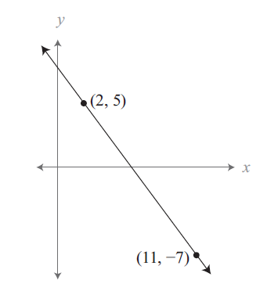
13. [11 correct answers] What is the slope of the line containing the points (2, 5) and (11, −7)? Express your answer as a common fraction.

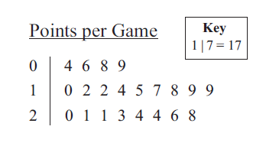
15. [8 correct answers] The stem-and-leaf plot shows the points a basketball player scored in 21 games. What is the player’s median number of points scored per game?

16. [4 correct answers] Sam is going to perform a juggling act for Crichton Middle School’s talent show. The performance will involve juggling three balls, each a different color. Sam must choose from red, blue, green, orange, purple and brown balls. How x`many different sets of three balls can Sam choose?

21. [3 correct answers] What is the sum of all positive four-digit integers ABCD such that the two-digit numbers AB, BC and CD are each perfect squares?
Target Round
4. [0 correct] Cecilia read consecutive pages of a 60-page comic book, and the sum of the page numbers she read was 300. What is the sum of all possible values for the page number of the final page that she read?

6. [0 correct] Ethan draws four cards from a standard 52-card deck without replacement. What is the probability that no two of them will be the same rank or the same suit? Express your answer as a common fraction.

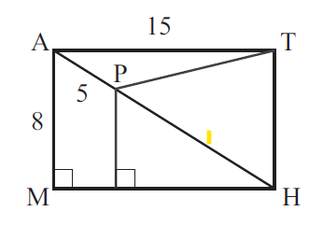
8. [2 correct] Rectangle MATH shown below has AM = 8 units, AP = 5 units and AT = 15 units. What is the area of triangle PTH? Express your answer as a common fraction.

AMC 8
16. [1 correct] Consider all positive four-digit integers consisting of only even digits. What fraction of these integers are divisible by 4?

18. [5 correct] In how many ways can 60 be written as the sum of two or more consecutive odd positive integers that are arranged in increasing order?

19. [7 correct] Miguel is walking with his dog, Luna. When they reach the entrance to a park, Miguel throws a ball straight ahead and continues to walk at a steady pace. Luna sprints toward the ball, which stops by a tree. As soon as the dog reaches the ball, she brings it back to Miguel. Luna runs 5 times faster than Miguel walks. What fraction of the distance between the entrance and the tree does Miguel cover by the time Luna brings him the ball?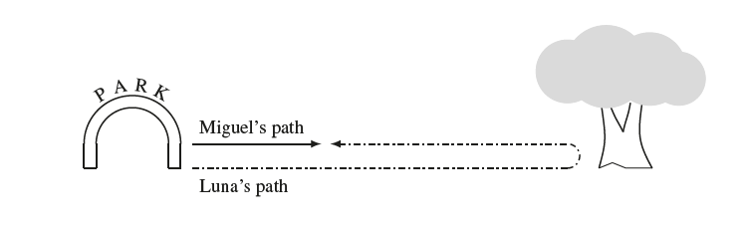
20. [4 correct] The land of Catania uses gold coins and silver coins. Gold coins are 1 mm thick and silver coins are 3 mm thick. In how many ways can Taylor make a stack of coins that is 8 mm tall using any arrangement of gold and silver coins, assuming order matters?

21. [5 correct] Charlotte the spider is walking along a web shaped like a 5-pointed star, shown in the figure below. The web has 5 outer points and 5 inner points. Each time Charlotte reaches a point, she randomly chooses a neighboring point and moves to that point. Charlotte starts at one of the outer points and makes 3 moves (re-visiting points is allowed). What is the probability she is now at one of the outer points of the star?
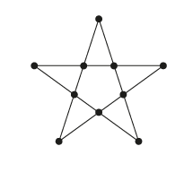
24. [2 correct] The notation n! (read “n factorial”) is defined as the product of the first n positive integers. (For example, 3! = 1·2·3 = 6.) Define the superfactorial of a positive integer, denoted by n!, to be the product of the factorials of the first n integers. (For example, 3! = 1! · 2! · 3! = 12.) How many factors of 7 appear in the prime factorization of 51!, the superfactorial of 51 ?

25. [2 correct] In an equiangular hexagon, all interior angles measure 120◦. An example of such a hexagon with side lengths of 2, 3, 1, 3, 2, and 2 is shown below, inscribed in equilateral triangle ABC. Consider all equiangular hexagons with positive integer side lengths that can be inscribed in △ABC, with all six vertices on the sides of the triangle. What is the total number of such hexagons? Hexagons that differ only by a rotation or a reflection are considered the same.
